You are given the heads of **two sorted linked lists**list1 and list2.

**Merge** the two lists in a one **sorted** list. The list should be made by splicing together the nodes of the first two lists.

Return *the head of the* ***merged linked list*.**

**Example 1:**

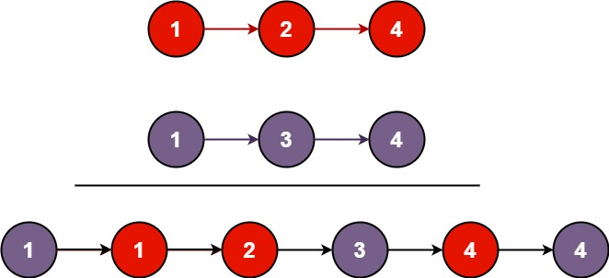

**Input:** list1 = [1,2,4], list2 = [1,3,4]

**Output:** [1,1,2,3,4,4]

**Example 2:**

**Input:** list1 = [], list2 = []

**Output:** []

**Example 3:**

**Input:** list1 = [], list2 = [0]

**Output:** [0]

Solution:

class Solution {

    public ListNode mergeTwoLists(ListNode l1, ListNode l2) {

        if (l1 == null) return l2;

        if (l2 == null) return l1;

        ListNode dummy = new ListNode(0);

        ListNode tail = dummy;

        while (l1 != null && l2 != null) {

            if (l1.val < l2.val) {

                tail.next = l1;

                l1 = l1.next;

            } else {

                tail.next = l2;

                l2 = l2.next;

            }

            tail = tail.next;

        }

        if (l1 != null) tail.next = l1;

        if (l2 != null) tail.next = l2;

        return dummy.next;

    }

}